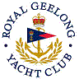 | Royal Geelong Yacht Club Inc.  Est 1859
Trophy Deed of Gift.

Trophy: | T. & N. Otway Perpetual Trophy
Presented by:
Date: | 1975
For: | Head of the Yarra
Remarks / Revisions | Now winner of Trials for National Championship..

